**Student Depression Dashboard – Python Data Visualization Project**

**About the Project**

This project explores student depression through data visualization using Python. I used pandas and matplotlib in Jupyter Notebook to analyze factors such as academic pressure, sleep habits, financial stress, and suicidal thoughts. Although I initially planned to use Seaborn, I adapted to technical limitations by building every chart with matplotlib and still achieved clear, colorful results.

### Goal

The goal of this dashboard is to analyze student mental health and depression through multiple factors such as academic stress, sleep, CGPA, financial burden, and city of residence. It’s meant to support better decision-making for student wellness initiatives.

### Technology

**Tools:** Python, Pandas, Matplotlib  
**Skills:** Data Visualization, Exploratory Data Analysis, and Dashboard Design

**What I Did**

After uploading and cleaning the dataset, I developed nine unique visualizations to uncover patterns and correlations related to depression. Each chart explores one variable or relationship to help identify which factors might influence or be associated with student depression.

**Dashboard Overview & Interpretation**

1. **Gender Distribution**  
   I created a pie chart to show the proportion of male and female students in the dataset. This gave me a quick sense of gender balance, which is important when analyzing group comparisons. The chart showed a fairly balanced but slightly female-dominated group.

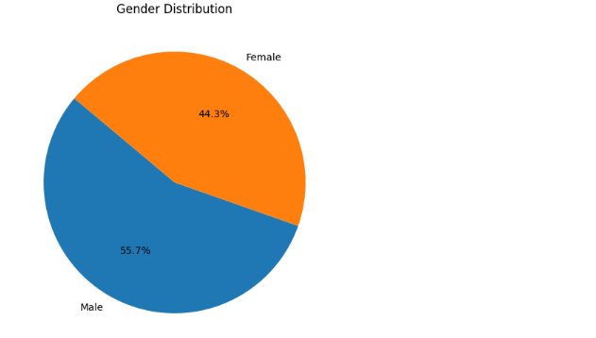

1. **Depression by Gender**  
   A bar chart displayed the number of students experiencing depression within each gender. I observed that depression cases were slightly more prevalent among female students, which may reflect real-world patterns or sampling differences.

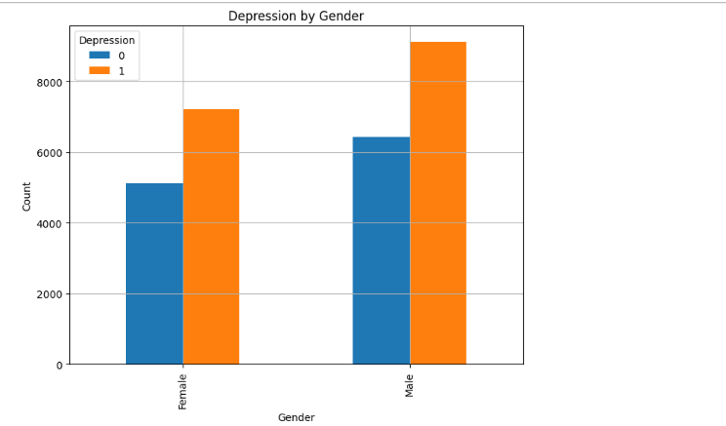

1. **Academic Pressure by Depression**  
   Using a boxplot, I compared the academic pressure scores between depressed and non-depressed students. The results suggested that students with depression tend to report slightly higher academic pressure, supporting the assumption that stress in school might be a contributing factor.

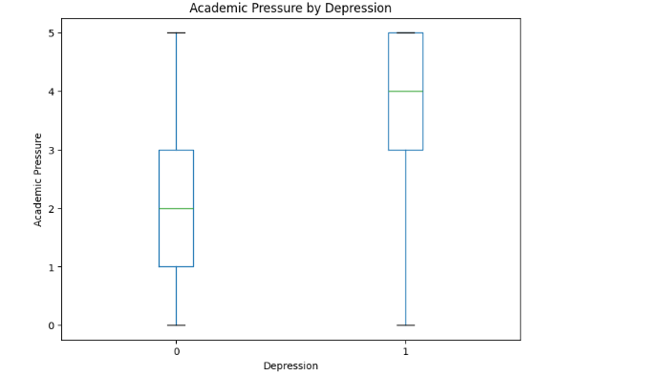

1. **CGPA by Depression**  
   I used a scatter-style strip plot to explore CGPA values by depression status. While there wasn’t a strong visual correlation, it appeared that students with lower GPAs were slightly more likely to experience depression.

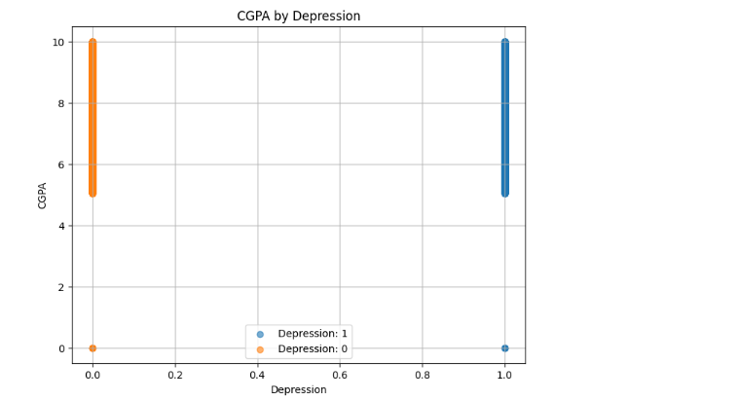

1. **Sleep Duration vs. Depression**  
   A grouped bar chart showed the relationship between reported sleep duration and depression. Students getting less than 5 hours of sleep had noticeably higher depression rates, highlighting sleep deprivation as a possible risk factor.

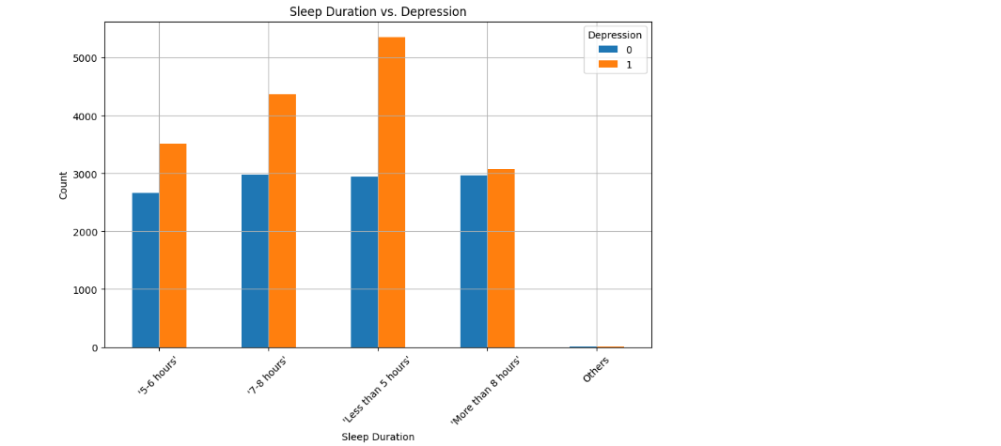

1. **Study Satisfaction vs. Depression**  
   I visualized how satisfied students felt with their studies and how that related to depression. Students with low study satisfaction were far more likely to report depressive symptoms, indicating that personal motivation and contentment with education could influence mental health.

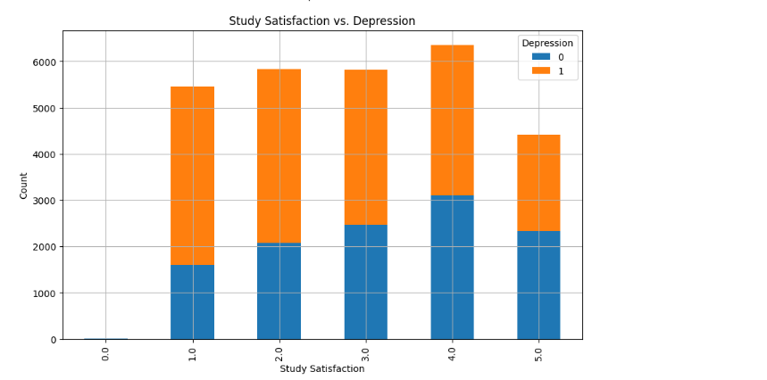

1. **Financial Stress vs. Depression**  
   Using a heatmap-like matrix, I looked at how different levels of financial stress aligned with depression. The highest depression counts occurred in students with extreme financial stress, suggesting that money-related anxiety might worsen mental health conditions.

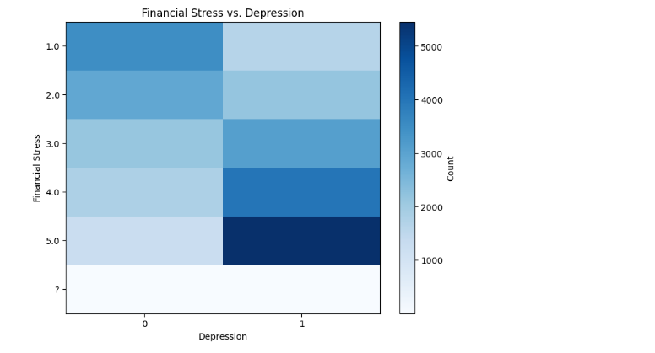

1. **Suicidal Thoughts vs. Depression**  
   This bar chart compared suicidal thoughts with depression diagnoses. Unsurprisingly, most students who reported suicidal thoughts also had depression, reinforcing the strong link between these two serious mental health concerns.

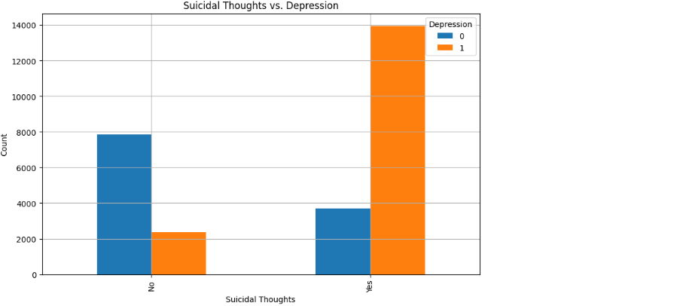

1. **Distribution**

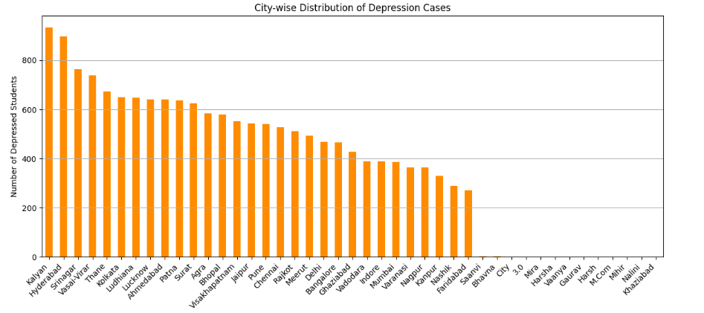

1. **Summary Dashboard**  
   I combined all the key charts into a single summary view using subplots. This dashboard allows for quick scanning and pattern recognition across all the different variables, and it helped me connect the dots between overlapping factors like stress, satisfaction, and sleep.

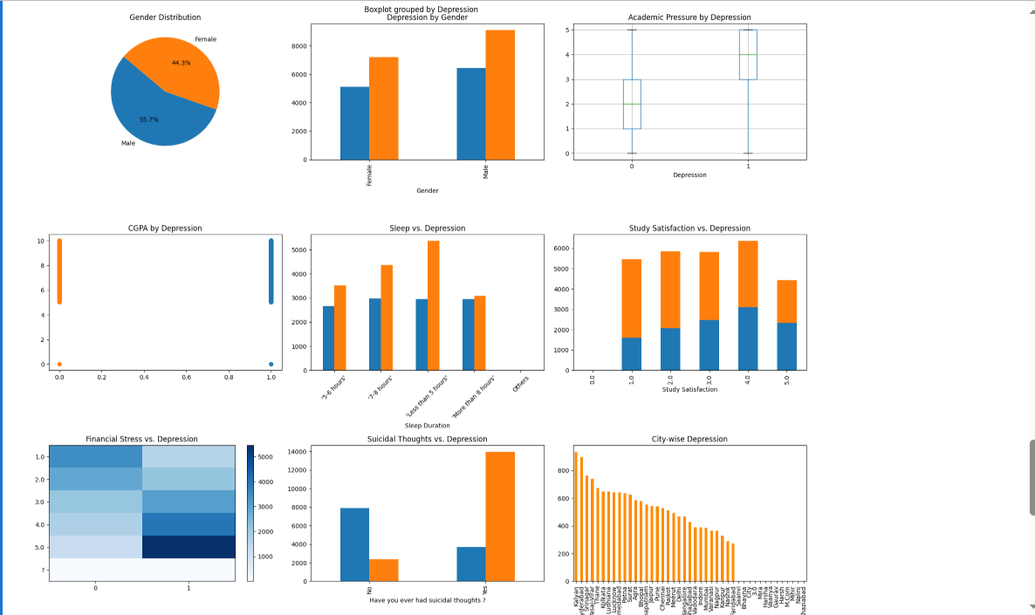

## Conclusion

This Python dashboard helped me explore multiple dimensions of student mental health using data. It strengthened my ability to create clean, meaningful visualizations even with tool limitations, and emphasized how data can guide wellness strategies in academic environments.